Pack Your Purse

A Real-Time / Field-Based Research Project (22AM284) report submitted to the Jawaharlal Nehru Technological University, Hyderabad

Submitted by

AKHILA SABAVATH 23B81A66D1
NOOLI NAINIKA 23B81A66F3
PADAM NANDINI PATEL 23B81A66F4

Under the guidance of
Mrs.G.Sirisha
Assistant Professor

DEPARTMENT OF CSE (ARTIFICIAL INTELLIGENCE & MACHINE LEARNING)

CVR COLLEGE OF ENGINEERING

CVR COLLEGE OF ENGINEERING
(An Autonomous institution , NAAC Accredited and Affiliated to JNTUH, Hyderabad)
Vastunagar,Mangalpalli(V),Ibrahimpatnam(M), Rangareddy (D), Telangana- 501 510

DEPARTMENT OF CSE (ARTIFICIAL INTELLIGENCE & MACHINE LEARNING)

CERTIFICATE

This is to certify that the Real time/ Field-Based research project(22AM284) report entitled “Pack Your Purse” is a record of work carried out by AKHILA SABAVATH, NOOLI NAINIKA, PADAM NANDINI PATEL submitted to Department of CSE (ARTIFICIAL INTELLIGENCE & MACHINE LEARNING), CVR College of Engineering, affiliated to Jawaharlal Nehru Technological University, Hyderabad during the year 2024-2025.

Project Guide Project Coordinator Head of the Department
Mrs.G.Sirisha Dr. R. Usha Rani
Asst.Prof. Professor
CSE(AI&ML) CSE(AI&ML)

DECLARATION

We hereby declare that the Real time/ Field-Based research project (22AM284) report entitled “Pack Your Purse” is an original work done and submitted to
CSE (ARTIFICIAL INTELLIGENCE & MACHINE LEARNING) Department, CVR College of Engineering, affiliated to Jawaharlal Nehru Technological University, Hyderabad and it is a record of bonafide project work carried out by us under the guidance of Mrs.G.Sirisha, Asst.Prof. , CSE(AI&ML).

We further declare that the work reported in this project has not been submitted, either in part or in full, for the award of any other degree or diploma in this Institute or any other Institute or University.

Signature of the Student
AKHILA SABAVATH
23B81A66D1

Signature of the Student
NOOLI NAINIKA
23B81A66F3
Signature of the Student
P. NANDINI PATEL
23B81A66F4

Place:

Date:

ACKNOWLEDGEMENT

We are thankful and fortunate enough to get constant encouragement, support, and guidance from all Teaching staff of CSE (ARTIFICIAL INTELLIGENCE & MACHINE LEARNING) Department who helped us in successfully completing this project work.

We thank Ms.K.Anuradha, Mr. Moghal Irfan Pasha, Project Coordinators, for their valuable guidance and support which helped us to complete the project work successfully.

We respect and thank our internal guide, Mrs.G.Sirisha, Asst.Prof. ,CSE(AI&ML) for giving us all the support and guidance, which made us complete the project duly.
We would like to express heartful thanks to Dr. R. Usha Rani, Professor & Head of the Department, for providing us an opportunity to do this project and extending support and guidance

We would like to express heartful thanks to Dr. H. N. Lakshmi, Professor & Associate Dean,ET for providing us an opportunity to do this project and extending support and guidance.

We thank our Vice-Principal Prof. L. C. Siva Reddy for providing excellent computing facilities and a disciplined atmosphere for doing our work.

We wish a deep sense of gratitude and heartfelt thanks to Dr. Rama Mohan Reddy, Principal and the Management for providing excellent lab facilities and tools. Finally, we thank all those guidance helpful to us in this regard.
LIST OF FIGURES

FIGURE | NAME OF FIGURE | PAGE NO
2.4.1 | Use Case Diagram | xiv
2.4.2 | Class Diagram | xv
2.4.3 | Activity Diagram | xvi
2.4.4 | Sequence Diagram | xvii
ABSTRACT

This Pack Your Purse application aims to simplify the entire process by providing an all-in-one platform to assist travelers in organizing their trips within a specified budget. By integrating multiple functionalities, such as budget management, itinerary planning, and real-time recommendations, the system delivers a comprehensive solution for travel enthusiasts.
The platform enables users to input essential travel parameters, including budget, the number of people, and the duration of the trip (days and nights). Based on this data, the system generates tailored recommendations for traveling expenses (including round-trip transportation), hotel stays, meals, popular tourist attractions, shopping hubs, and local transportation options. Each recommendation is accompanied by detailed pricing to help users stay within their budget. The system also includes a feature to add notes, allowing users to sketch their daily itinerary. Additionally, a built-in language translation tool facilitates easy communication with locals, ensuring a smoother travel experience in foreign destinations.
This Pack Your Purse not only enhances user convenience but also promotes cost-effective and well-organized travel planning. Its focus on offering personalized recommendations and real-time updates sets it apart from traditional planning methods, making travel an enjoyable and stress-free experience
TABLE OF CONTENTS

Chapter No. |  | Contents | Page No.
 |  | Certificate | i
 |  | Declaration | ii
 |  | Acknowledgement | iii
 |  | List of Figures | iv
 |  | List of Tables (if any) | v
 |  | Abstract | vi
1 |  | Introduction | viii
 | 1.1 | Problem Statement | viii
 | 1.2 | Project Objectives | ix
 | 1.3 | Software &Hardware specifications | x
 | 1.3.1 | Software requirements | x
 | 1.3.2 | Hardware requirements | x
2 |  | Design Methodology | xi
 | 2.1 | System Architecture | xi
 | 2.2 | Data flow Diagram or Flowchart | xii
 | 2.3 | Technology Description | xiii
3 |  | Implementation & Testing | xviii
 | 3.1 | Code snippets | xviii
 | 3.2 | Test cases | xxi
4 |  | Conclusion | xxvi
 |  | Bibliography | xxvi
 |  | Appendix: ( Source code ) | xxvii

CHAPTER 1: INTRODUCTION

Pack Your Purse is a web-based travel expense management and itinerary planning application designed to simplify and enhance the travel planning experience. Travelers often struggle to organize cost-effective trips while managing bookings, transportation, sightseeing, and budgeting. This platform offers an all-in-one solution by allowing users to input trip details like budget, duration, and group size to generate optimized travel recommendations.
It provides suggestions for transportation, accommodation, meals, attractions, and shopping — all within the specified budget. The application also includes features like a daily itinerary planner and a built-in language translator for smoother communication abroad. With a user-friendly interface and real-time assistance, Pack Your Purse ensures well-organized, affordable, and stress-free travel for all users.

1.1 PROBLEM STATEMENT
Planning a trip can be overwhelming due to the numerous factors involved — managing the budget, selecting suitable accommodations, organizing daily activities, estimating travel expenses, and dealing with language barriers in foreign locations. Travelers often rely on multiple apps and manual research, which can lead to confusion, overspending, or missed opportunities. There is a lack of a centralized platform that offers personalized, budget-friendly travel planning with integrated tools to enhance convenience and decision-making. Moreover, real-time adaptability and the absence of multilingual support in traditional tools further complicate the travel experience. A unified solution is essential to streamline these elements and empower users to plan trips efficiently and confidently. These are the primary reasons why travel planning remains complicated and stressful for many users:
- Disjointed Planning Tools
- Budgeting Challenges
- Lack of Personalization
- Language Barriers
- Absence of Real-Time Adaptability

1.2 PROJECT OBJECTIVES

The main objective of Pack Your Purse is to create a unified platform that simplifies travel planning while ensuring affordability, convenience, and personalization. The project aims to cater to the essential needs of modern travelers by offering a range of integrated features. The specific objectives include:
1. Budget-Based Travel Planning
To develop a system that allows users to input their total budget, trip duration, and group size, and receive customized travel recommendations that stay within those financial constraints.
2. Personalized Itinerary Creation
To provide users with the ability to design daily itineraries based on interests and preferences, including sightseeing, food, shopping, and relaxation, with an option to take notes and make real-time adjustments.
3. Centralized Expense Management
To automate cost calculations and give users a breakdown of expenses across transportation, accommodation, meals, and other activities, ensuring transparent and controlled spending.
4. Integration of Real-Time Travel Recommendations
To include dynamic, location-based suggestions such as nearby attractions, local food joints, or events, helping users make the most of their trip while staying informed.
5. Built-in Language Translation Support
To embed a translation feature that allows users to communicate with locals in their native language, reducing language-related barriers and improving overall travel experience.
6. Simplified User Interface and Experience
To ensure the platform is intuitive, responsive, and accessible across different devices, making travel planning easy for users of all tech backgrounds.

1.3 SOFTWARE AND HARDWARE SPECIFICATIONS

The following section outlines the necessary software tools and hardware components required for the successful implementation and execution of the project.

1.3.1 Software Specifications:

- Languages:
  - HTML & CSS for building the user interface.
  - JavaScript for adding interactivity and dynamic content.
  - Python for backend development and logic handling.
- Database:
  - MySQL to store user data, travel preferences, and itinerary information.
- Development Tools & IDE:
  - Visual Studio Code for code editing.
  - MySQL Workbench for database management.
  - Git for version control to track changes and collaborate.

1.3.2 Hardware Specifications:

- System Requirements:
  - RAM: Minimum 8 GB for smooth multitasking.
  - Storage: At least 500 GB of hard disk space.
  - Processor: Intel i5 or equivalent for optimal performance.
- Supported Operating Systems:
  - Windows 10 or later, macOS, and Linux.

CHAPTER 2 :DESIGN METHODOLOGY

2.1 SYSTEM ARCHITECTURE
User Input & Initialization
• Users provide trip details like budget, duration, and group size through a responsive web interface.
• Built using HTML, CSS, and JavaScript.
Backend Processing
• Python backend processes inputs and applies logic to generate budget-friendly travel suggestions.
• Filters transportation, accommodation, meals, and attractions based on user preferences.
Itinerary & Note Management
• Personalized itineraries are generated day-wise.
• Users can add or edit notes to plan activities for each day.
Translation Integration
• A translation API helps users interact with locals in different languages.
• Supports real-time communication for a smoother travel experience.
Expense Tracking
• Tracks estimated and actual expenses in various categories.
• Updates dynamically to help users manage spending.
Deployment
• Application deployed using Django (Python), MySQL for data storage, and accessible across major OS platforms.

2.2 DATA FLOW DIAGRAM OR FLOW CHART

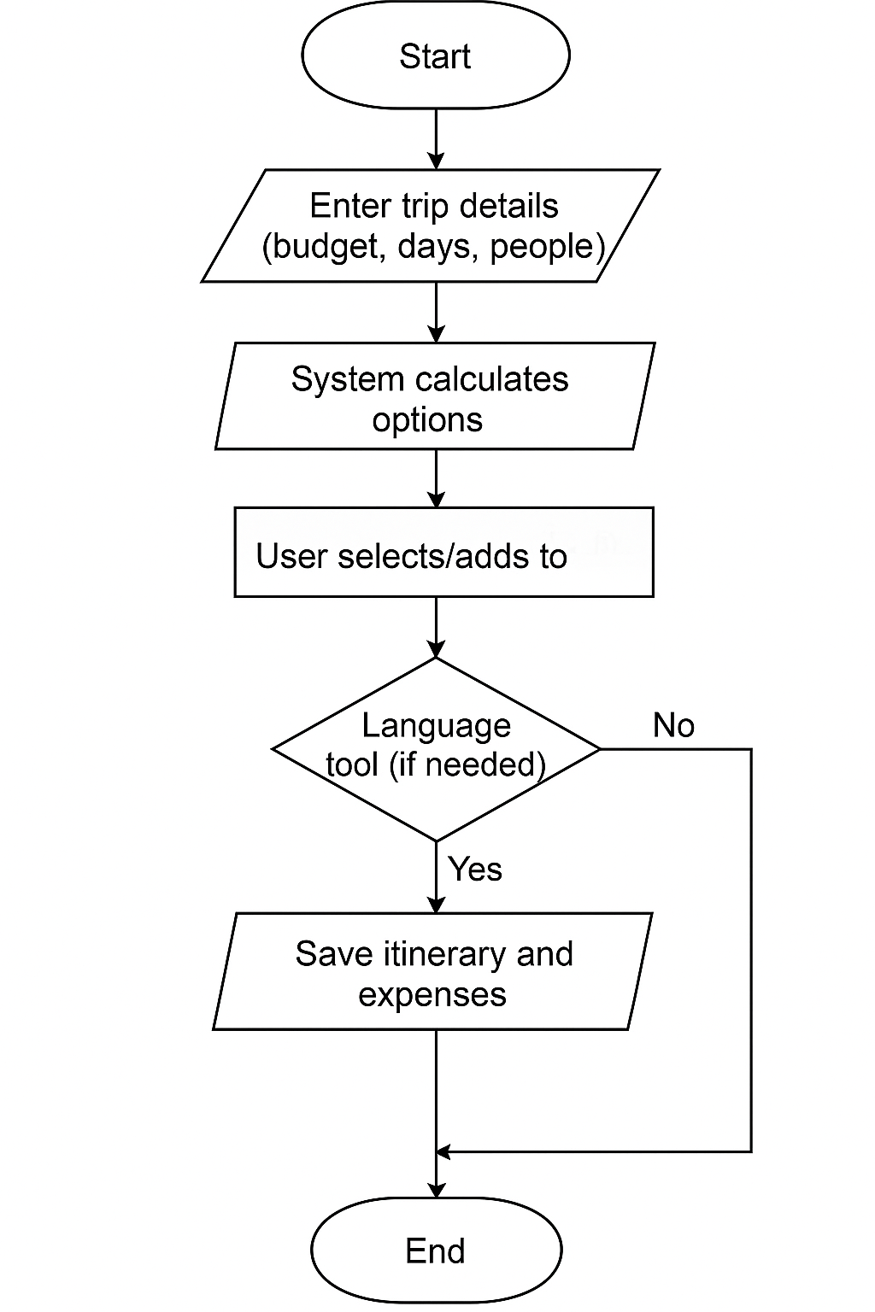

2.3 TECHNOLOGY DESCRIPTION

Frontend:
- HTML/CSS – Structure and styling of the web interface.
- JavaScript – For interactivity, dynamic content rendering, and validation.
Backend:
- Python – Handles data processing, logic implementation, and APIs.
- Framework suggestion: Flask (lightweight and easy) or Django (feature-rich and secure).
Database:
- MySQL – Relational database used to manage structured data like user info, travel plans, and expenses.
APIs & Tools:
- Translation API (like Google Translate API) – Helps users communicate in foreign languages.
- Google Maps API (optional) – For location-based recommendations.
- Git – Version control for collaborative development.
- Visual Studio Code – IDE for coding and debugging.
- MySQL Workbench – GUI tool for database management.

2.4 UML DIAGRAMS

2.4.1 USECASE DIAGRAM

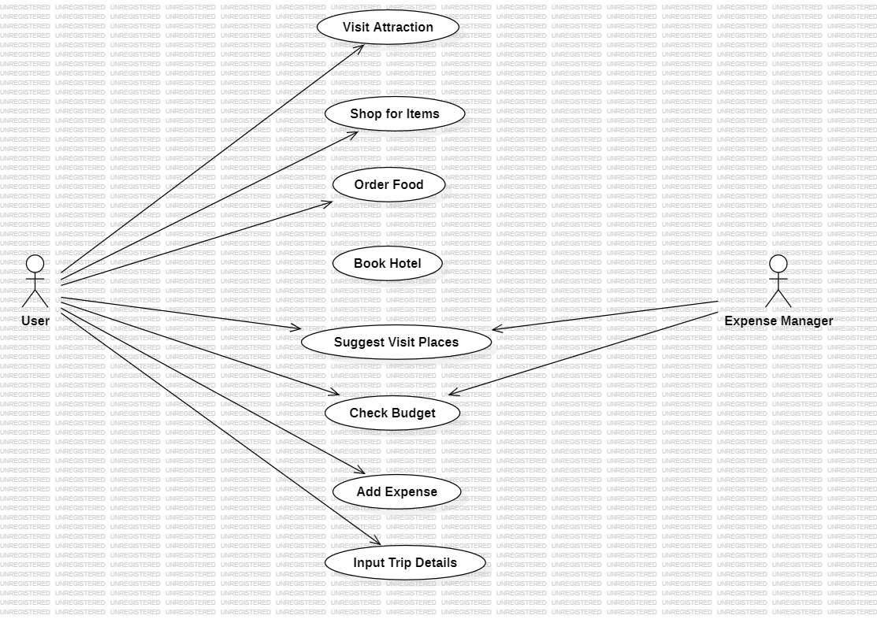

2.4.2 CLASS DIAGRAM

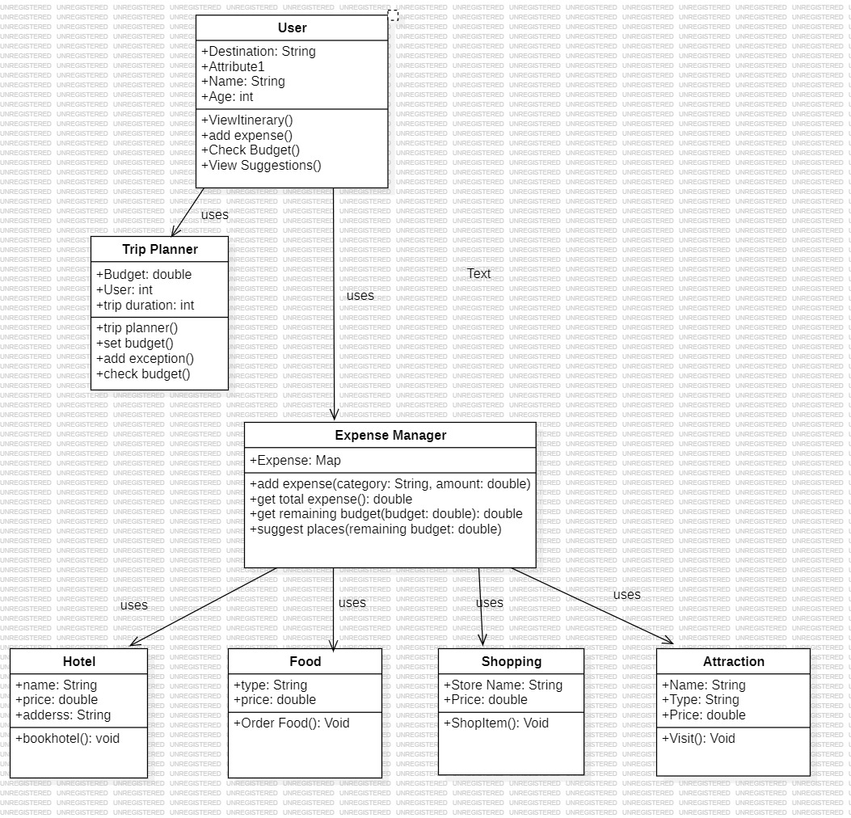
2.4.3 ACTIVITY DIAGRAM

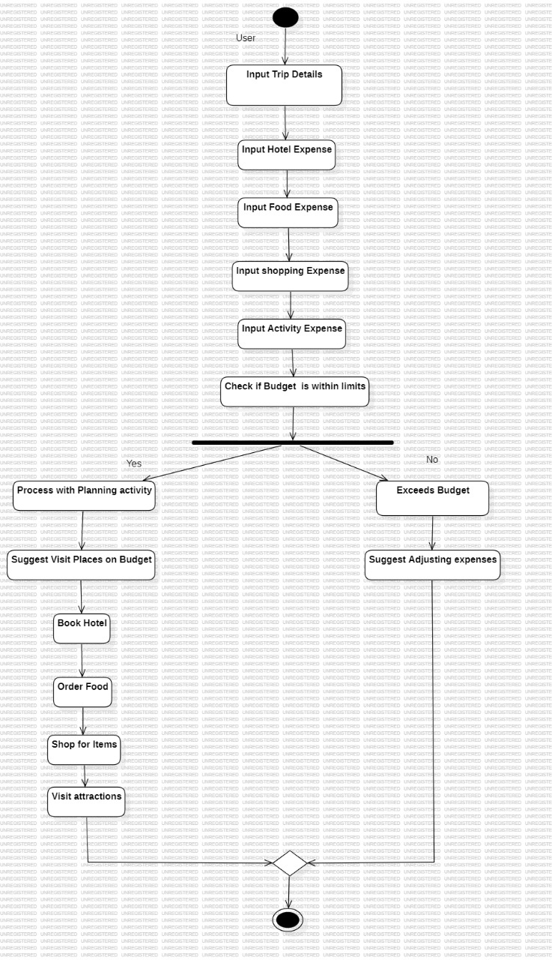

2.4.4 SEQUENCE DIAGRAM

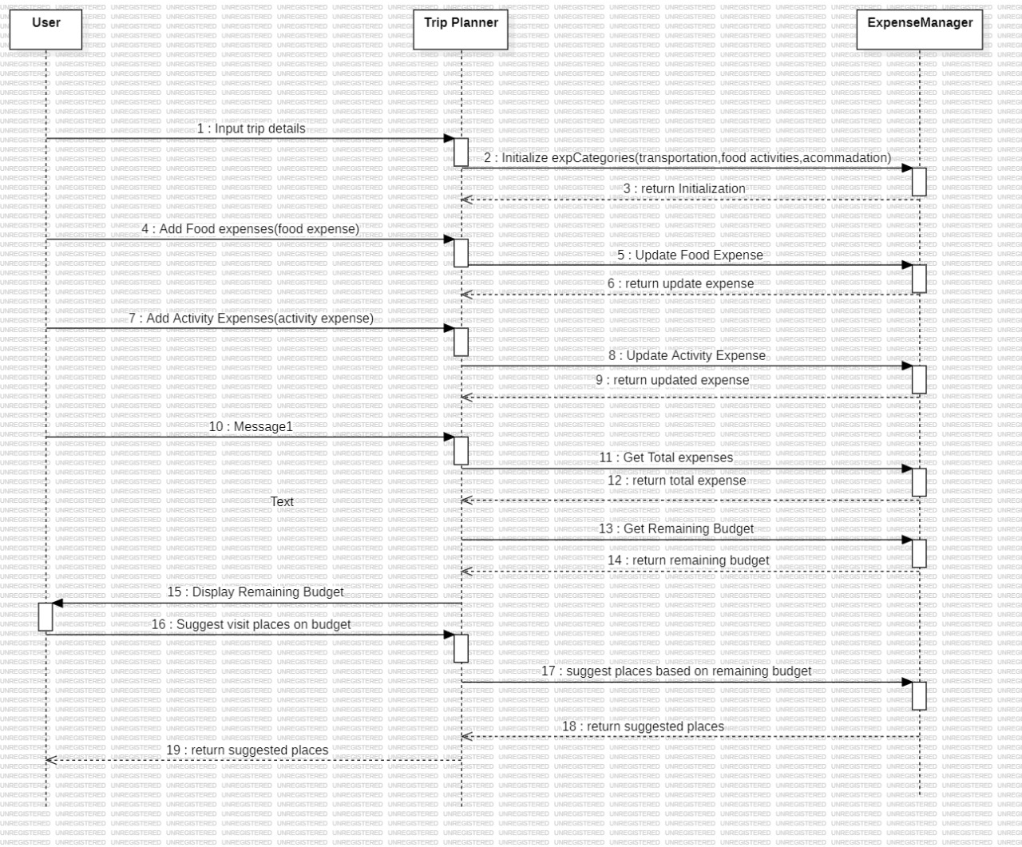

CHAPTER 3:IMPLEMENTATION AND TESTING

3.1 CODE SNIPPETS
1. Base
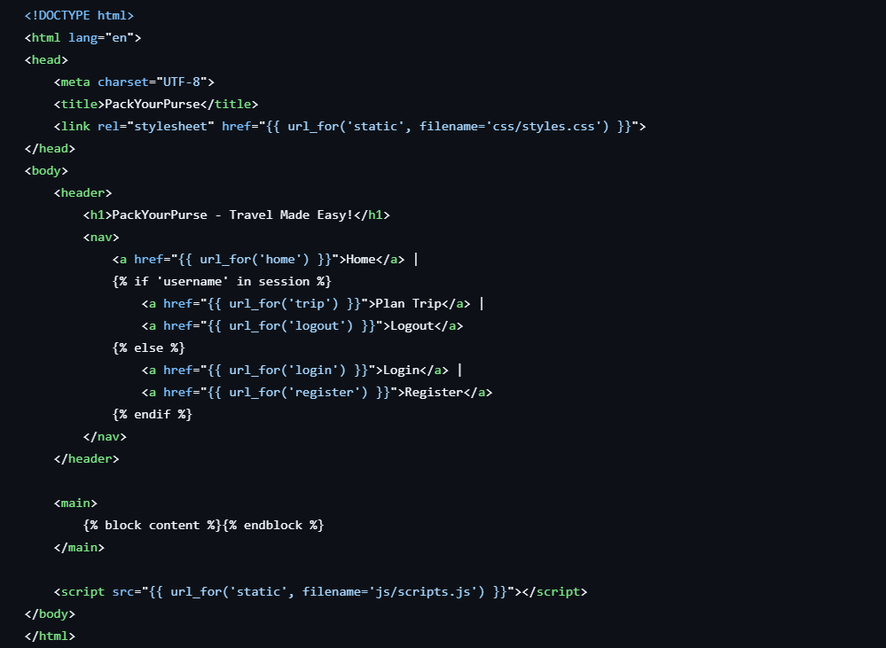
2. Registration
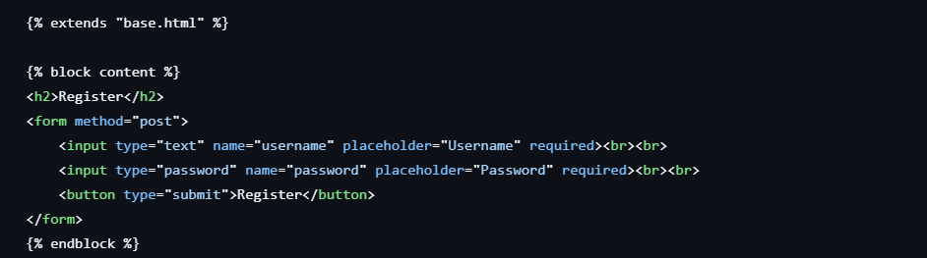
3.Login
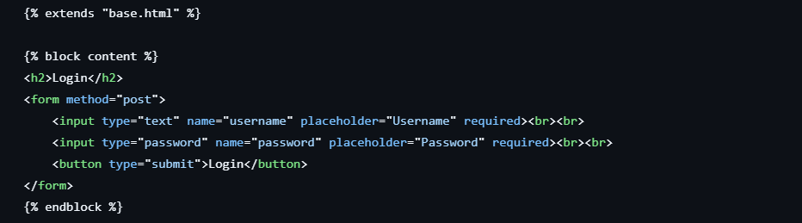
4.DashBoard
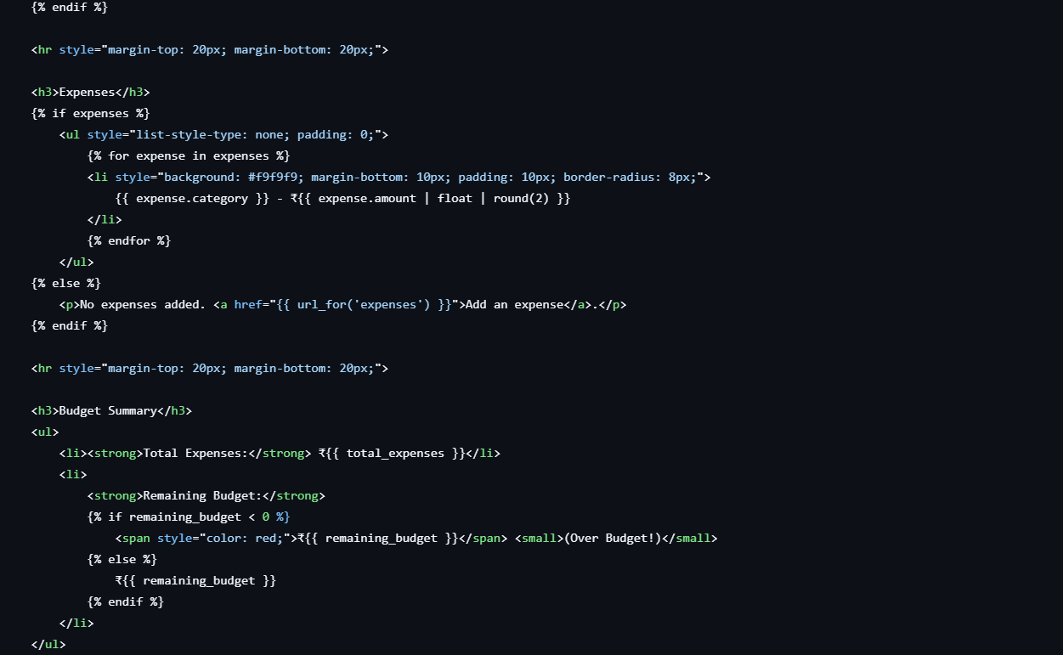
5. Plan a Trip
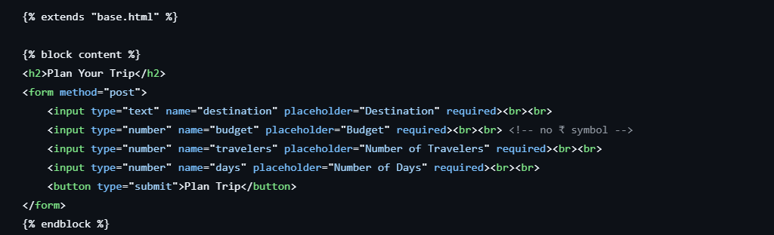
6.Expenses
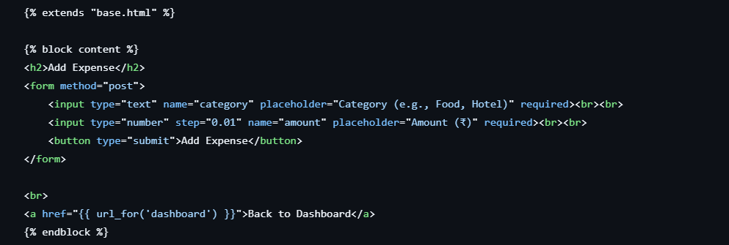
3.2 TEST CASES
1.open the app, the home page gets displayed
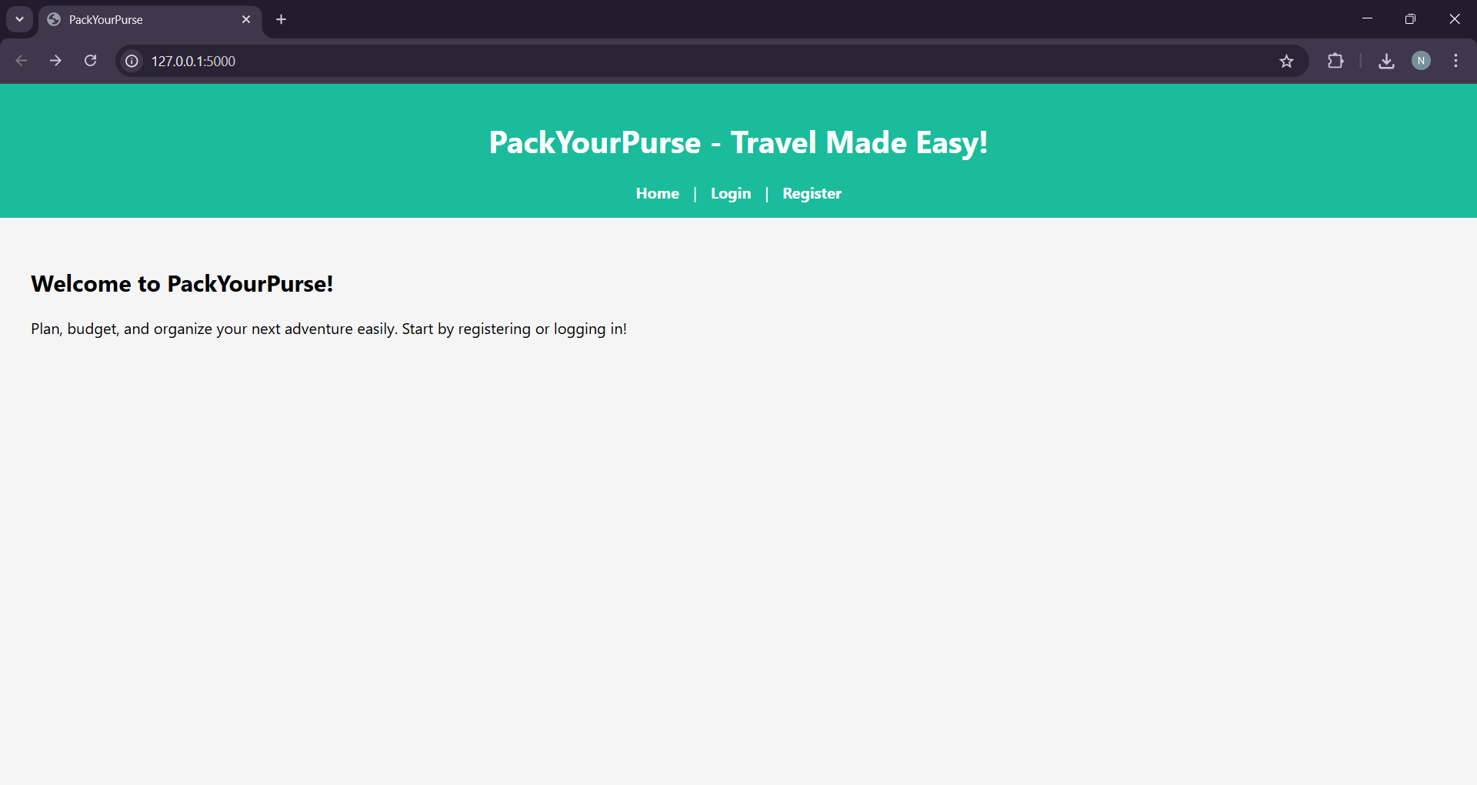
2.Select Login Page and fill your details
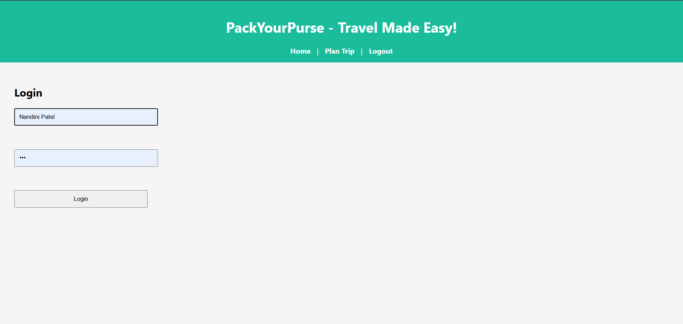

3.Now,click register to start your trip planning .
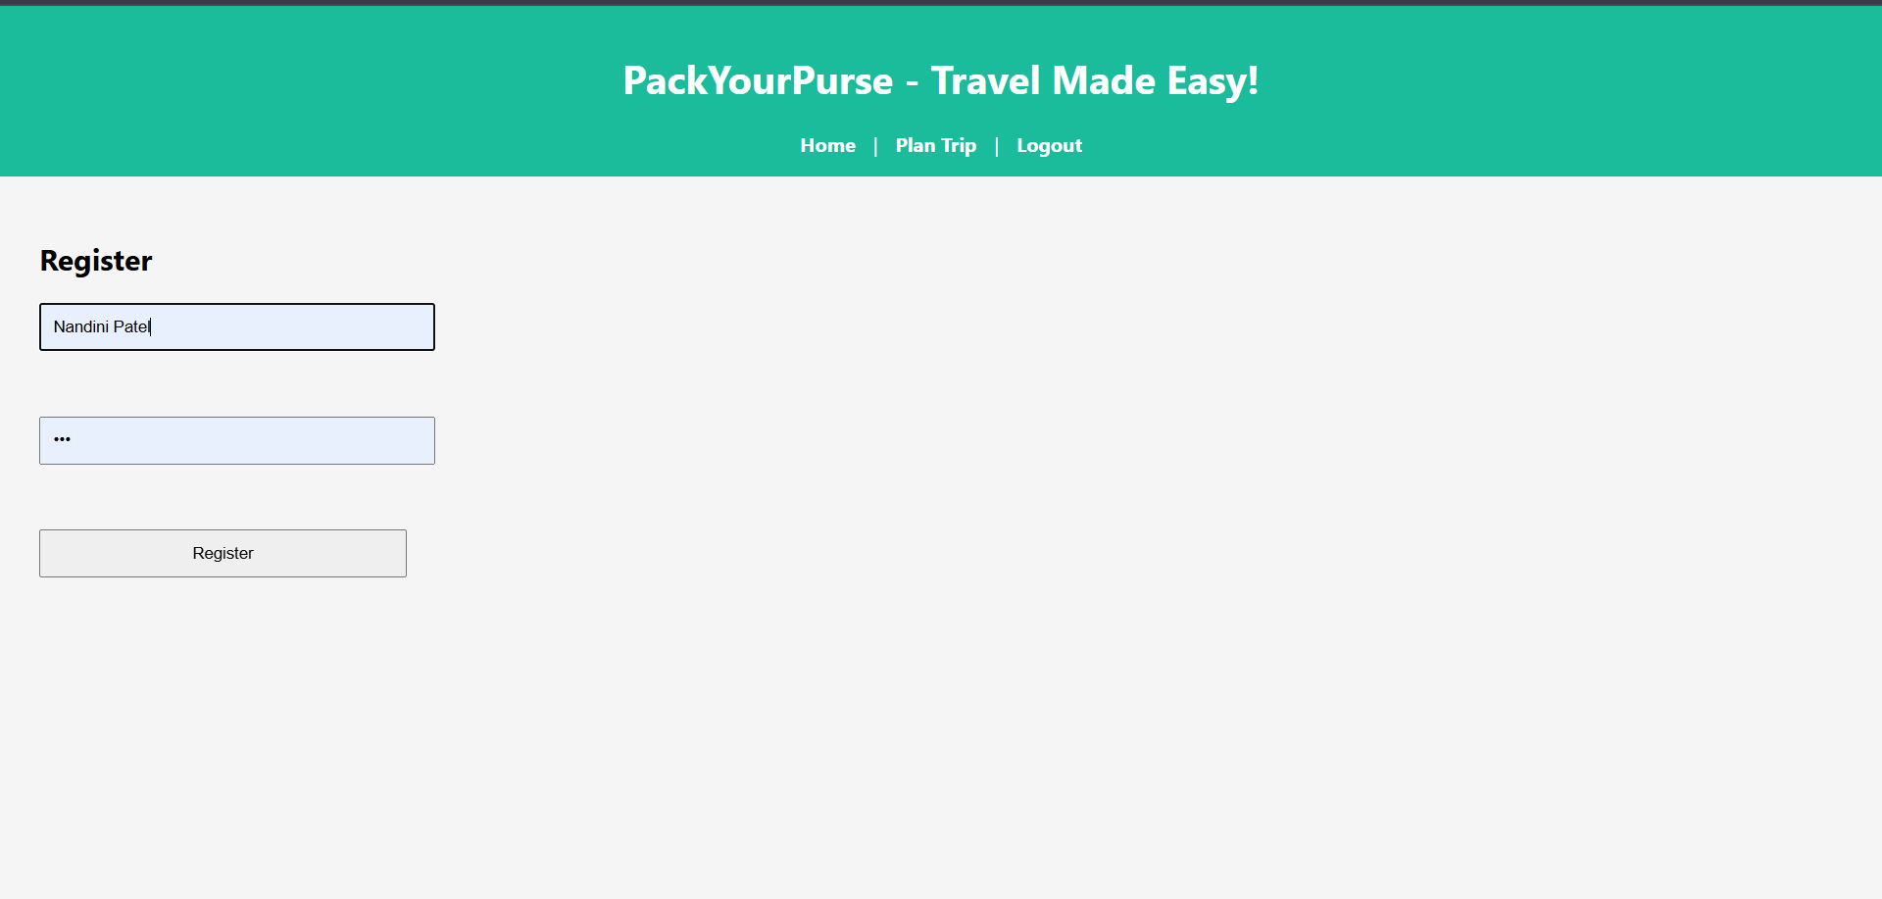
4.Plan Your Trip
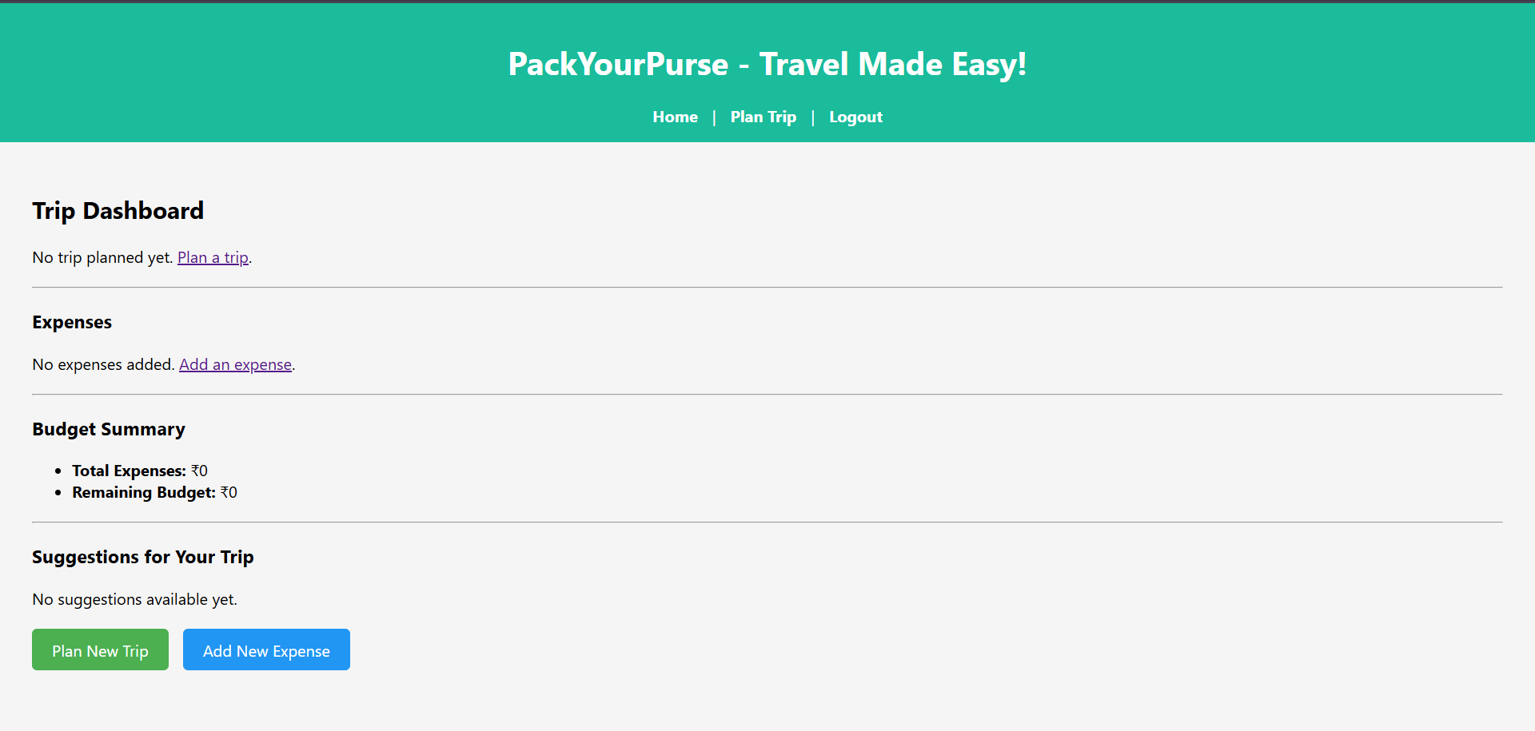
5.Fill the form to get your trip details
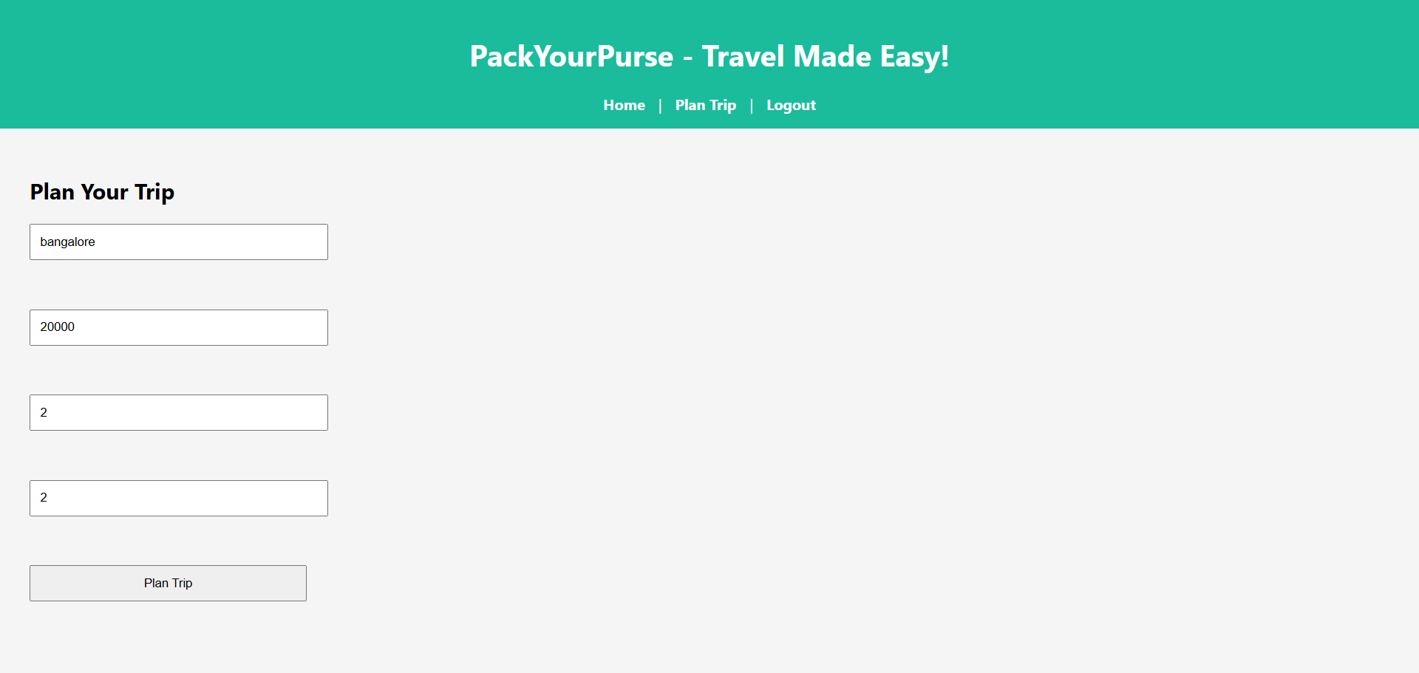
6.Now click on the expenses and enter the details
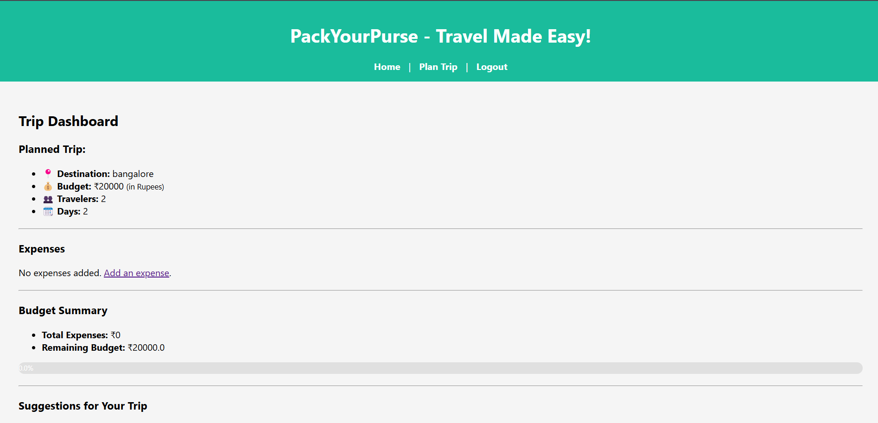
7.Give all your expenses on food,hotel,travel etc
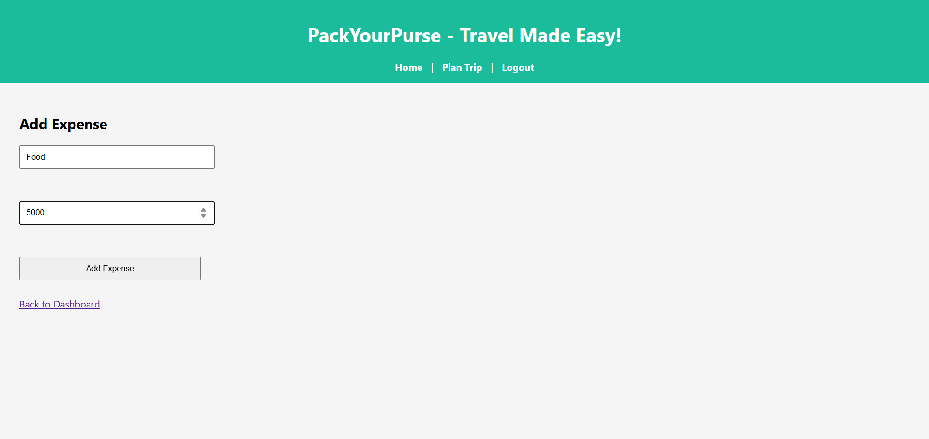
8.Add all the expenses according to the budget you have entered
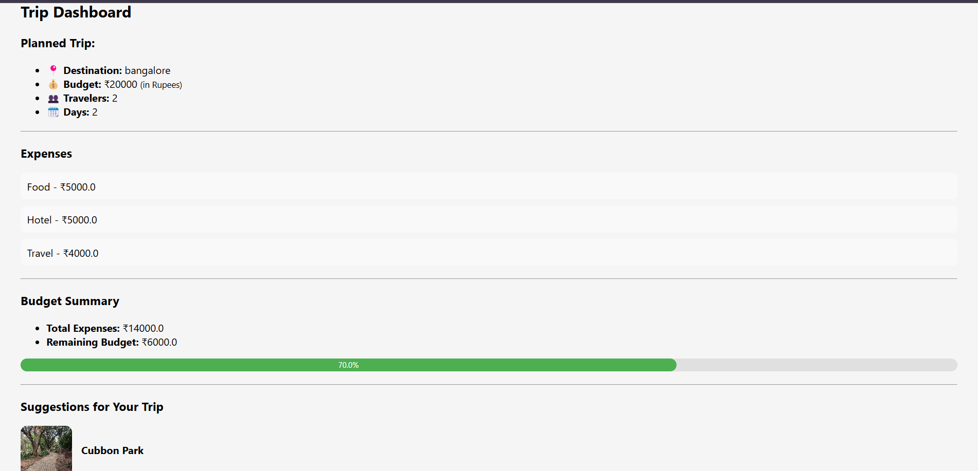

9.All the expenses will be calculated and distributed according to your input
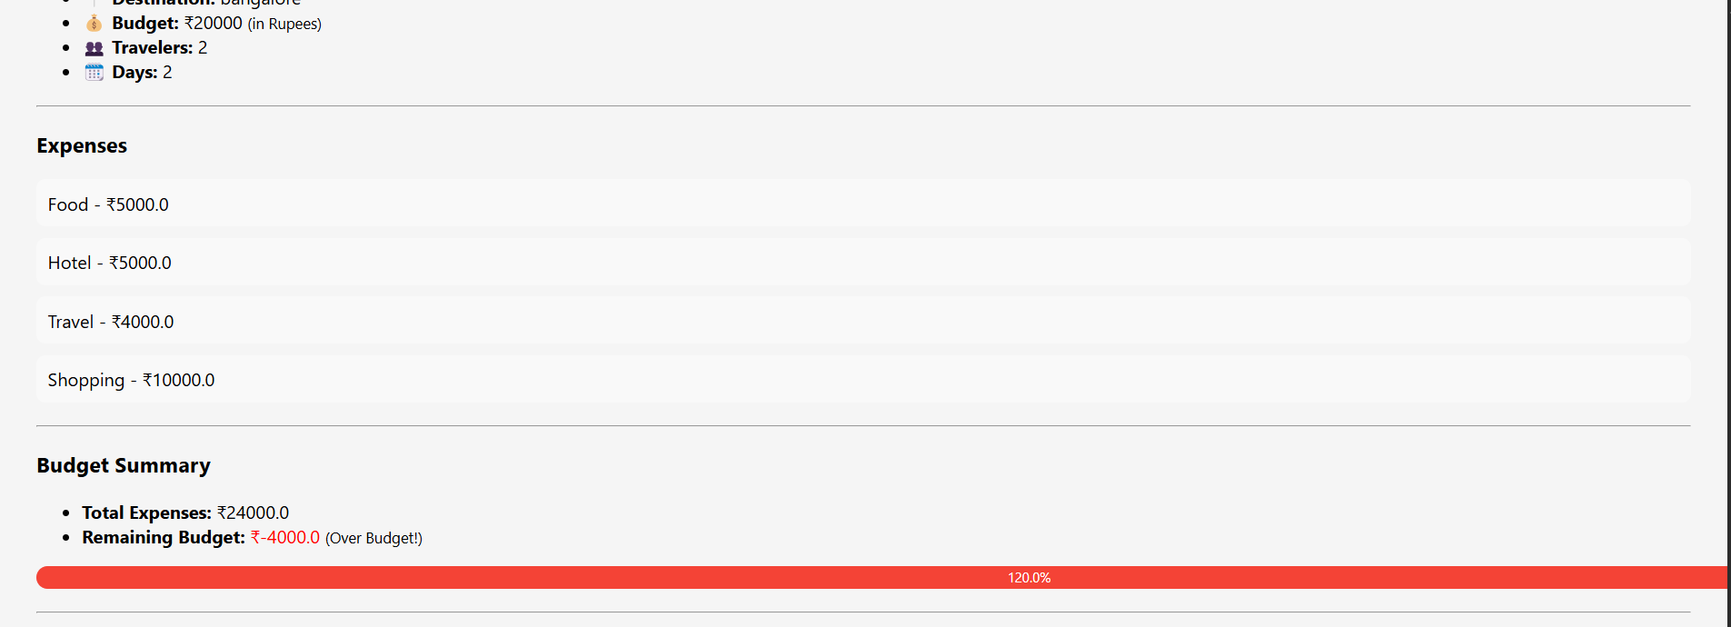

10.After entering all your details, a suggestion trip will be displayed according to the budget
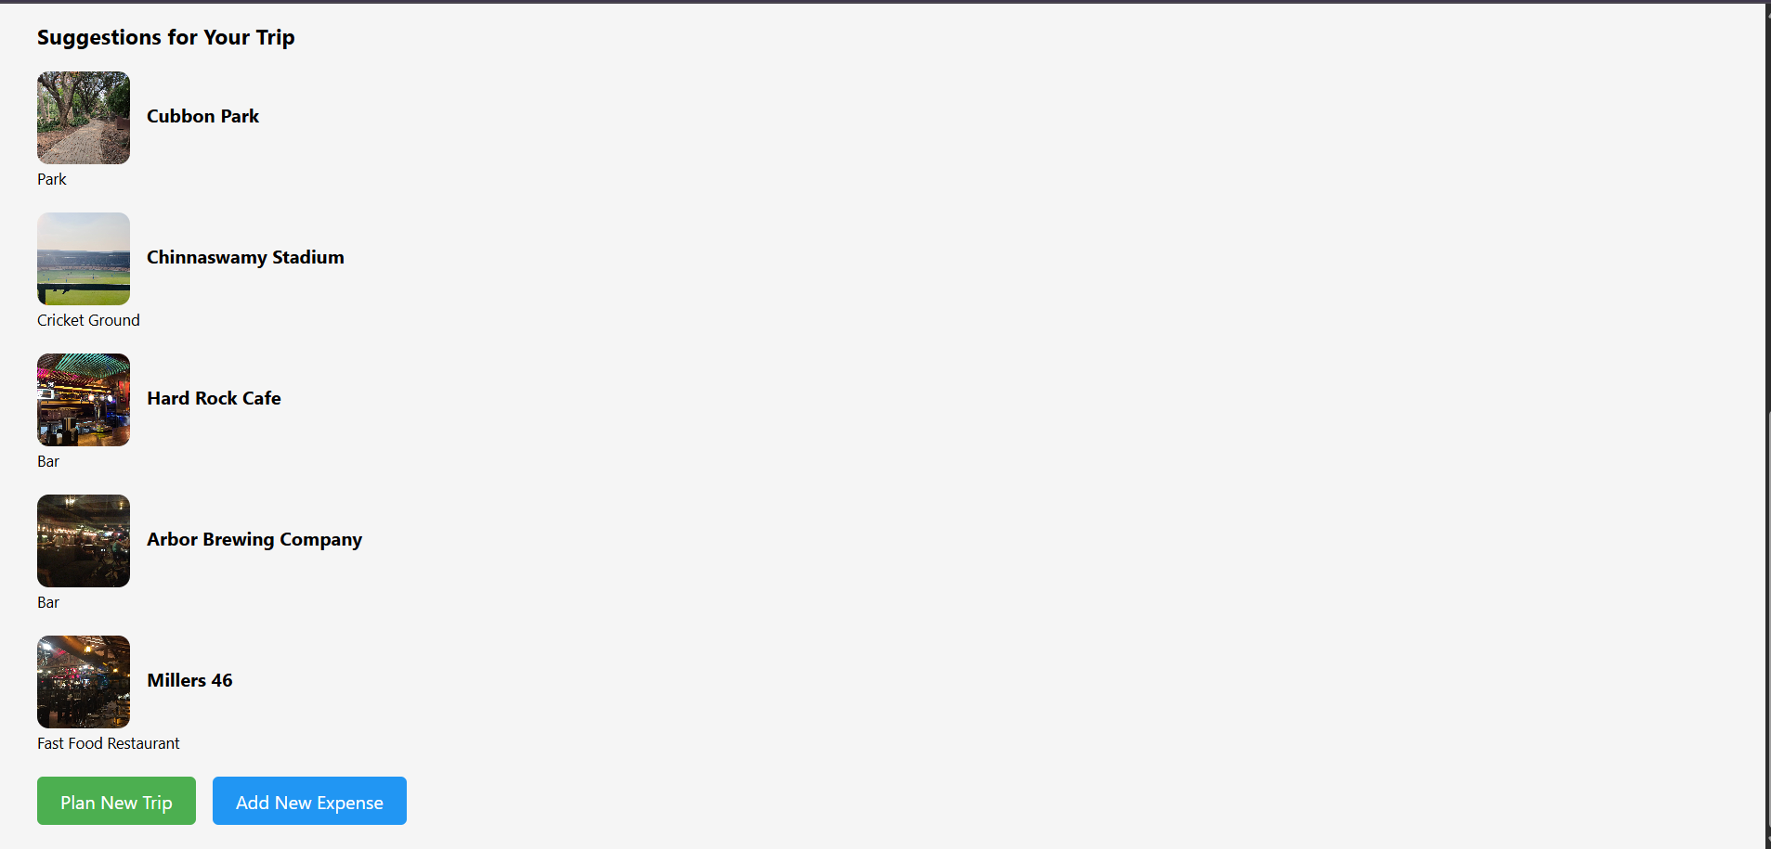
CHAPTER 4
CONCLUSION
The Pack Your Purse application provides a comprehensive and user-centric solution for modern travel planning. By integrating essential travel tools such as budget management, itinerary planning, expense tracking, and real-time recommendations into a single platform, the application simplifies the entire process of organizing a trip. Its emphasis on personalized suggestions and multilingual support ensures a smoother, more enjoyable travel experience for users, even in unfamiliar destinations. Overall, Pack Your Purse empowers travelers to make informed decisions, stay within budget, and create well-structured travel plans with minimal stress and maximum efficiency.
This project showcases the practical application of web development technologies in solving real-world problems. It highlights how thoughtful design and user-focused features can significantly enhance convenience. As a future enhancement, integration with APIs for live data and bookings could further improve the platform’s functionality and relevance.
BIBILIOGRAPHY
1. Flask Documentation – https://flask.palletsprojects.com/en/stable/
2. Python Documentation – https://docs.python.org/3/
3. JavaScript MDN Web Docs –https://developer.mozilla.org/enUS/docs/Web/JavaScript
4. HTML Living Standard – https://html.spec.whatwg.org/
5. CSS MDN Docs – https://developer.mozilla.org/en-US/docs/Web/CSS
APPENDIX

1.GitHub link - https://github.com/Nandini-Patel09/PYP

2.Install Dependencies:

3.Run The Application:

4. Key Files in the Repository:

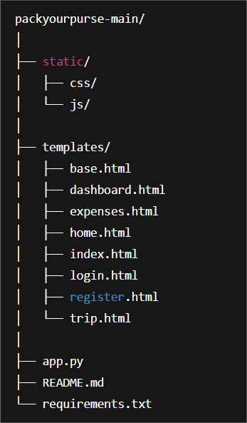

5.Access the application:

- Open your web browser and navigate to: http://127.0.0.1:5000
- Register a new account or login with existing credentials
- Start Planning your Trip
SOURCE CODE

